How to connect Python to Oracle Database:
To connect python with oracle two components are required. First the library required is "cx_Oracle" with compatible version. But this library is not enough on its own to communicate with oracle db. It redirects the communication to what is called "Oracle Client Libraries". The cx_Oracle library is python specific but "Oracle Client Libraries" is not. So first download cx_Oracle in command mode using pip as follows:
- Open command prompt
- Type "pip install cx_Oracle", pip will install cx_Oracle 7 (in my case) to the path specified in the environment [in my case C:\Anaconda3\Lib\site-packages\cx_Oracle-7.1.2.dist-info]
OR
Type "conda install -c anaconda cx_oracle" (in special case)

Now we are to install another library "Oracle Client Libraries". In this context we have to download "Oracle instant client for Windows 64" (as my OS is Windows 10), as follows:
- Open chrome
- Type "oracle instant client for windows 64 bit". A list of suggestions appears
- Select "Instant Client for Microsoft Windows (x64) 64-bit - Oracle
https://www.oracle.com/technetwork/topics/winx64soft-089540.html"
- Oracle site opens
- Accept licence agreement. Login to Oracle account and download appropriate "instantclient-basic-windows.x64.zip" file.
- Unzip the file in the path "C:\Anaconda3\instantclient_11_2"
- Copy this path to the environment variable above all the Oracle entry. For example, "C:\Oracle10g\app\oracle\product\10.2.0\server\bin
- Open Komodo and go to "View -> Preferences -> Environment".
- Go to user environment variables and edit the path as "C:\Anaconda3\ instantclient_11_2" beginning of the existing path entry
- Restart Komodo
- Type "import cx_Oracle"
- Type "conn = cx_Oracle.connect('hr/hr@localhost:1521/xe')"

THIS IS FOR PYCHARM IDE

Follow These Steps to Install and Import CX_Oracle Package in PyCharm:
- Get your Internet connection on
- Open PyCharm and then Open your project.
- Click on the menu File > Settings and then the Settings window will open.
- In the Settings window, click on the Project node to expand and then click on the "Project Interpreter".
- Then on the right side, click on the '+' button to open Available Packages window, as shown in below image. Then search for "cx_Oracle" (or "cx-Oracle" if "cx_Oracle" is not found. Pay attention on the 'Hyphen' not on 'Underscore') in the search box. Below you will find the "cx_Oracle" or "cx-Oracle" package. Click on it to select and then click on the "Install Package" button as shown below:
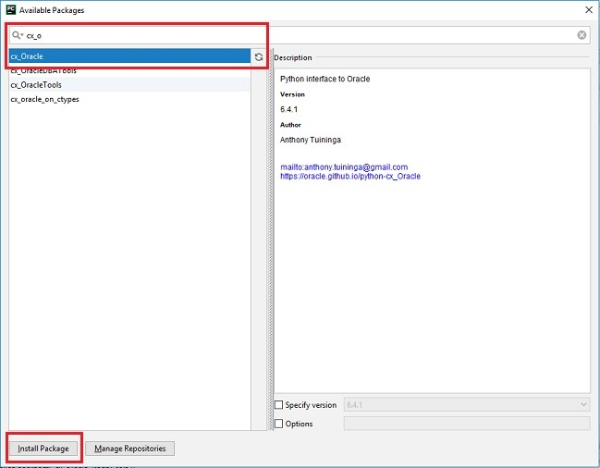
You have installed the "cx_Oracle" package, and now you can use it in your Python applications by importing it. Import "cx_Oracle" in PyCharm Example:

import cx_Oracle #Notice that here always be "cx_Oracle" not "cx-Oracle"

How to connect Python to MySQL Database:
To connect python with MySQL the component required is MySQL Connector". So download "mysql-connector" library in command mode using pip as follows:
- Open command prompt
- Type "pip3 install mysql-connector-python" or "pip install mysql-connector-python"
- Open Komodo and type the code:
import mysql.connector
mydb=mysql.connector.connect(user="root",password='chinmoy',database='sakila')

THIS IS FOR PYCHARM IDE

Follow These Steps to Install and Import CX_Oracle Package in PyCharm:
- Get your Internet connection on
- Open PyCharm and then Open your project.
- Click on the menu File > Settings and then the Settings window will open.
- In the Settings window, click on the Project node to expand and then click on the "Project Interpreter".
- Then on the right side, click on the '+' button to open Available Packages window, as shown in below image. Then search for "mysql-connector" in the search box. Below you will find the "mysql-connector" package. Click on it to select and then click on the "Install Package" button as shown below:

- After installing "mysql-connector" package search for "mysql-connector-python" in the search box. To be noted the "mysql-connector" package to be installed first followed by "mysql-connector-python".

You have installed the "mysql-connector" and "mysql-connector-python" packages, and now you can use it in your Python applications by importing it. Import "mysql.connector" in PyCharm Example:

import mysql.connector

Connector/Python Connection Arguments:
A connection with the MySQL server can be established using either:
- mysql.connector.connect() function [e.g. cnx = mysql.connector.connect(user='root', database = 'sakila')
- mysql.connector.MySQLConnection() class [e.g. cnx = MySQLConnection(user='root', database = 'sakila')
The following table describes the arguments that can be used to initiate a connection. An asterisk (*) following an argument indicates a synonymous argument name, available only for compatibility with other Python MySQL drivers. Oracle recommends not using these alternative names.
Connection Arguments for Connector/Python
Argument Name | Default | Description
user (username*) |  | The user name used to authenticate with the MySQL server.
password (passwd*) |  | The password to authenticate the user with the MySQL server.
database (db*) |  | The database name to use when connecting with the MySQL server.
host | 127.0.0.1 | The host name or IP address of the MySQL server.
port | 3306 | The TCP/IP port of the MySQL server. Must be an integer.
unix_socket |  | The location of the Unix socket file.
auth_plugin |  | Authentication plugin to use. Added in 1.2.1.
use_unicode | True | Whether to use Unicode.
charset | utf8 | Which MySQL character set to use.
collation | utf8_general_ci | Which MySQL collation to use.
autocommit | False | Whether to autocommit transactions.
time_zone |  | Set the time_zone session variable at connection time.
sql_mode |  | Set the sql_mode session variable at connection time.
get_warnings | False | Whether to fetch warnings.
raise_on_warnings | False | Whether to raise an exception on warnings.
connection_timeout(connect_timeout*) |  | Timeout for the TCP and Unix socket connections.
client_flags |  | MySQL client flags.
buffered | False | Whether cursor objects fetch the results immediately after executing queries.
raw | False | Whether MySQL results are returned as is, rather than converted to Python types.
consume_results | False | Whether to automatically read result sets.
ssl_ca |  | File containing the SSL certificate authority.
ssl_cert |  | File containing the SSL certificate file.
ssl_disabled | False | True disables SSL/TLS usage. Option added in Connector/Python 2.1.7.
ssl_key |  | File containing the SSL key.
ssl_verify_cert | False | When set to True, checks the server certificate against the certificate file specified by the ssl_ca option. Any mismatch causes aValueError exception.
ssl_verify_identity | False | When set to True, additionally perform host name identity verification by checking the host name that the client uses for connecting to the server against the identity in the certificate that the server sends to the client. Option added in Connector/Python 8.0.14.
force_ipv6 | False | When set to True, uses IPv6 when an address resolves to both IPv4 and IPv6. By default, IPv4 is used in such cases.
dsn |  | Not supported (raises NotSupportedError when used).
pool_name |  | Connection pool name. The pool name is restricted to alphanumeric characters and the special characters ., _, *, $, and #. The pool name must be no more than pooling.CNX_POOL_MAXNAMESIZE characters long (default 64).
pool_size | 5 | Connection pool size. The pool size must be greater than 0 and less than or equal to pooling.CNX_POOL_MAXSIZE (default 32).
pool_reset_session | True | Whether to reset session variables when connection is returned to pool.
compress | False | Whether to use compressed client/server protocol.
converter_class |  | Converter class to use.
failover |  | Server failover sequence.
option_files |  | Which option files to read. Added in 2.0.0.
option_groups | ['client', 'connector_python'] | Which groups to read from option files. Added in 2.0.0.
allow_local_infile | True | Whether to enable LOAD DATA LOCAL INFILE. Added in 2.0.0.
use_pure | False as of 8.0.11, and True in earlier versions. If only one implementation (C or Python) is available, then then the default value is set to enable the available implementation. | Whether to use pure Python or C Extension. If use_pure=False and the C Extension is not available, then Connector/Python will automatically fall back to the pure Python implementation. Can be set with mysql.connector.connect() but not MySQLConnection.connect(). Added in 2.1.1.

How to connect Python to Mongodb Database:
- Installation of Pymongo Library: pip install pymongo
- Write the following code into the python file:
#from pymongo import MongoClient
import pymongo
client=pymongo.MongoClient()
db=client["chinmoydb"] #database name
collection=db["emp"] #table name (known as collection)
cur=collection.find()
for m in cur: print(m['eno'],"|",m['ename'],"|",m['sal'],"|")

Installing Python django:
Important links:
Installing Django on Windows : https://docs.djangoproject.com/en/1.11/howto/windows/
Writing your first Django app : https://docs.djangoproject.com/en/1.11/intro/tutorial01/
Django "How to" Guides : https://docs.djangoproject.com/en/1.11/howto/

Steps:

- Launch "Windows PowerShell" as Administrator. To do so, type Windows PowerShell in the Cortana, right click on the Windows PowerShell option and click Run as Administrator.
- The following window will appear:
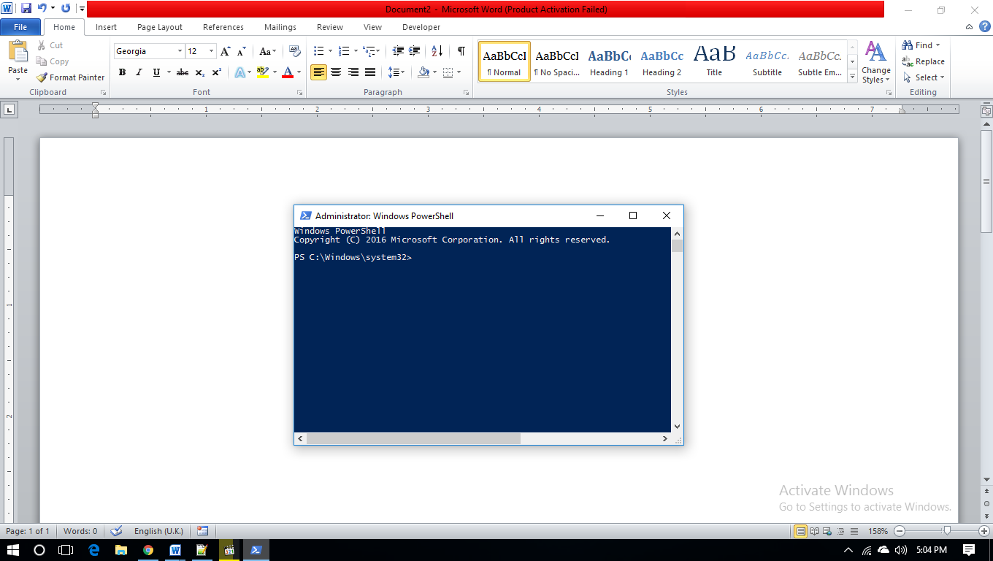
- Install virtualenv and virtualenvwrapper. To do so type the following text to the PowerShell prompt:
pip install virtualenvwrapper-win
- Then create a virtual environment for your project: to do so type:
mkvirtualenv myproject
- Now type in the following text to activate the environment as:
workon myproject
- Now we can install Django by writing the following text:
pip install django
- After installing django, to check the django version write the following command:
python -m django --version
- Now go to the path where we want to create our project. For example D:\djangoproject, by changing the drive to D: and getting into the djangoproject directory by typing the command 'cd djangoproject'.
- Now we can create our first project. To do so type:
django-admin startproject project_name. For example,
django-admin startproject computeracademy
- Now we have to get into our project as:
cd .\computeracademy\
- Now run server python as:
python manage.py runserver
We'll be given an IP address for localhost as 127.0.0.1:8000
- Now open browser (such as Google Chrome) and type on the address bar localhost:8000. Now we can develop and run our app.

Object Oriented Programming:
Classes and objects are the two main aspects of object oriented programming. A class creates a new type where objects are instances of the class. An analogy is that we can have variables of type int which translates to saying that variables that store integers are variables which are instances (objects) of the int class

Objects can store data using ordinary variables that belong to the object. Variables that belong to an object or class are referred to as fields. Objects can also have functionality by using functions that belong to a class. Such functions are called methods of the class. Collectively, the fields and methods can be referred to as the attributes of that class.

Fields are of two types - they can belong to each instance/object of the class or they can belong to the class itself. They are called instance variables and class variables respectively.

A class is created using the class keyword. The fields and methods of the class are listed in an indented block.

The self:
Class methods have only one specific difference from ordinary functions – they must have an extra first name that has to be added to the beginning of the parameter list, but we do not give a value for this parameter when we call the method, Python will provide it. This particular variable refers to the object itself, and by convention, it is given the name self. Although, one can give any name for this parameter, it is strongly recommended that he should use the name "self" - any other name is definitely frowned upon.

We must be wondering how Python gives the value for self and why we don’t need to give a value for it. An example will make this clear. Say we have a class called MyClass and an instance of this class called myobject. When we call a method of this object as myobject.mymethod(arg1, arg2), this is automatically converted by Python into MyClass.mymethod(myobject, arg1, arg2) and the method is to be defined as
def mymethod(self, arg1, arg2). Therefore,

- Method definition : def mymethod(self, arg1, arg2)
- Method calling statement : myobject.mymethod(arg1, arg2)
- Python's interpretation : MyClass.mymethod(myobject, arg1, arg2)

This also means that if we have a method which takes no arguments, then we still have to have one argument - the "self".

